Практическая работа №13
Задание 1.
numbers = [10, 5, 17, 3, 8]
print(numbers)

numbers.extend([2, 6, 3, 14, 10, 4, 11, 16, 12, 5, 4, 16, 1, 0, 8, 16, 10, 10, 8, 5, 1, 11, 10, 10, 12, 0, 0, 6, 14, 8, 2, 12, 14, 5, 6, 12, 1, 2, 10, 14, 9, 1, 15, 1, 2, 14, 16, 6, 7, 5])
print(numbers)

print(len(numbers))

print(numbers[-1])

print(numbers[::-1])

if 5 in numbers and 17 in numbers:
print("YES")
else:
print("NO")

print(numbers[1:-1])

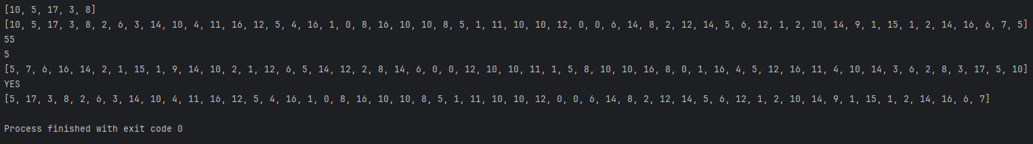

Задание 2.
n = int(input("Ведите кол-во строк: "))

all_chars = []

for i in range(n):

s = input("Введите символы строки: ")

all_chars.extend(s)

print(all_chars)

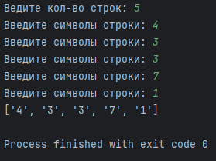

Задание 3.
path = input("Введите путь к файлу: ")

parts = path.split("\\")

for i in parts:
print(i)

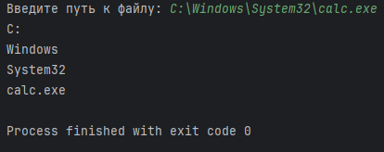

Задание 4.
ipaddress = input("Введите ip адрес: ")

parts = ipaddress.split(".")

for i in parts:
if int(i) < 0 or int(i) > 255:
print("НЕТ")
exit()

print("ДА")

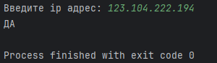
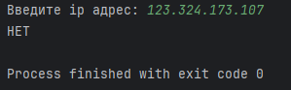

input_string = input("Введите целые числа : ")

numbers_str = input_string.split()

numbers = []
for num_str in numbers_str:
numbers.append(int(num_str))

pairs_count = 0
i = 0

while i < len(numbers) - 1:
if numbers[i] == numbers[i + 1]:
pairs_count += 1
i += 2
else:
i += 1

print(f"Количество пар: {pairs_count}")

